HAU Project Collaborations at Mississippi State University
Introduction and Background
In April 2024, 6 MEng students from Harper Adams University visited Mississippi State University for a total of 2 weeks. During their time at the University, they were primarily based at the AAI (Agricultural Autonomy Institute) which is a recently established institute at the University.
The AAI has a large focus on Agricultural Autonomy, supporting Precision Agriculture and more sustainable farming practices. Contributions from industrial partners, researchers, academics and MSU students, MSU are working on a wide range of autonomy projects for different areas of agricultural needs in the industry. In an early push for an exchange of ideas within autonomous agriculture, Mississippi State University’s new Agricultural Autonomy Institute recently hosted a two-week international exchange with six students from the United Kingdom’s Harper Adams University, and MSU students will return the visit this June.
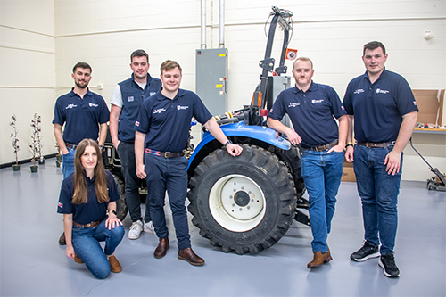
Over the 2 weeks, students were fortunate to meet a vast range of people, from fellow students, academics, industrial partners, University Alumni, and those involved in different areas of the University. The group worked closely with Madison Dixon, the Associate Director of MSU’s Agricultural Autonomy Institute, who expressed his thoughts on the collaboration and the aim. “We want to emulate and hopefully improve and expand upon the Hands Free Hectare concept at Harper Adams University here at the MSU Agricultural Autonomy Institute on our own Autonomous Acres Proving Ground at the Mississippi Agricultural and Forestry Experiment Station’s R.R. Foil Plant Science Research Center”.
Harper Adams University’s Kit Franklin provided the opportunity for the students, through some previous work of his own, and discussions led to the collaboration with HAU and MSU. “After some initial conversations about academic interaction during that visit, it was great to have this initial exchange arranged so quickly” Franklin stated.
The AAI Director, Alex Thomasson stated that the newly launched institute recognises the global importance of autonomous agriculture and is promoting student expertise and promoting the early exchange. “The new institute is working to foster international collaboration and innovation in agricultural autonomy as well as international exposure, academic networking and goodwill.”
The Projects
The key project for the students focused on improving the AAI’s autonomous New Holland TC33 tractor. Although a large task, the students, through the help of Dr. Hussein Gharakhani, provided support in many different aspects, from vision based systems for obstacle recognition, through to CAD for protection shields on steering systems, to mounting and fabrication of different parts and linkages for the newly modified actuation of the pedals. The students got a grasp of different areas of speciality in the department, and enjoyed collaborating with students and academics, all learning and progressing together, to together achieve a considerable task.
With each member of the group providing different aspects of knowledge, it was interesting to speak to like minded engineers from the University, who would have a different understanding of the problems faced. The Harper Students were able to advance the progress on multiple different projects, including a cotton harvesting module which the team also worked on.
The cotton harvesting robot is a significant advancement in technology and understanding of key principles when harvesting this unique crop. The robot uses AI Vision Systems and Machine Learning, GPS systems, Depth Perception Cameras and a unique end effector for harvesting the crop accurately, effectively and safely. The Harper Team supported through the use of CAD, software integration, product testing and practical fabrication.
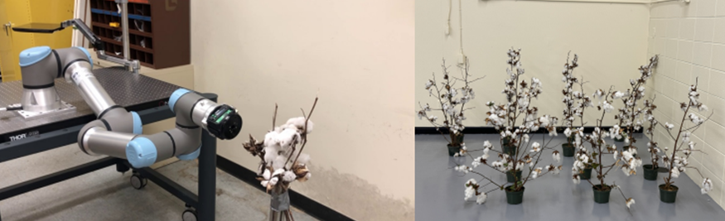
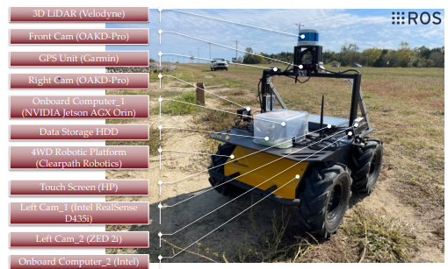

Networking
Attending multiple events, the students dived in to all the networking opportunities on offer, which included sports fixtures, lunch meetings, alumni breakfasts, and the impressive Athlete Engineering Summit. This Summit hosts athletes, academics, students, and specialist panel discussions to inform, and create a better understanding of the subject. Athlete engineering hosts 3 key athletes, those who compete in sports, the industrial athlete such as a production line employee, and finally the tactical / military athlete. Where a large focus was on human performance and improving this through the aids of wearable technologies and supports, through to key nutrition, sleep, and recovery to support people’s lives.
The students learnt a lot at the summit, and some interesting factors on AI, human performance, technology advancements, and maximising team efficiencies.
Key Takeaways
Some key take homes from the collaborating trip included:
The trip was an amazing opportunity to develop my knowledge in not only precision agriculture but AI and a different agricultural landscape. It was shocking to hear that they were struggling with the same labour shortages we are facing in the UK. Hence, the push for autonomous harvesting equipment. We encountered a vast range of different software’s whilst working at the AAI, although a challenge, it was an immense opportunity to learn about different technologies and support each other through collaboration between students. The culture is very different, it was impressive to experience a different student life, different rural areas, and all in all experiencing the differences across the pond, it really is fascinating.
The attendees go as follows:
- Rhodri Williams, MEng Agricultural Engineering, Whitland, West Wales.
- Luke Waldram, MEng Automotive (Off-Highway) Engineering, Bridgnorth, Shropshire.
- Harry Rigby, MEng Agricultural Engineering, Cheshire, England.
- Charlie Jackson MEng Agricultural Engineering, Derby, England.
- Dominic Neal, MEng Mechanical Engineering, Jersey Islands, United Kingdom.
- Kelly Billington, MEng Mechanical Engineering, Luton, Bedfordshire, England.
Conclusion
The AAI will continue to cultivate relationships with established and emerging researchers in agricultural autonomy to sponsor further research and development in Mississippi.
Attendees have since returned to Harper Adams University to continue their master dissertations, which will be due in the coming months.
In June, MSU attendees hope to participate in a return trip where they will attend Harper and assist projects on this side, again expanding the knowledge available and continue to collaborate between the 2 institutes.
A significant thank you to the Douglas Bomford Trust, Harper Adams University and Mississippi State University. The funding received from the DBT allowed the group to travel to the States, where without the funding this may not have been possible, thank you to the Trustees and the Trust, it is greatly appreciated!
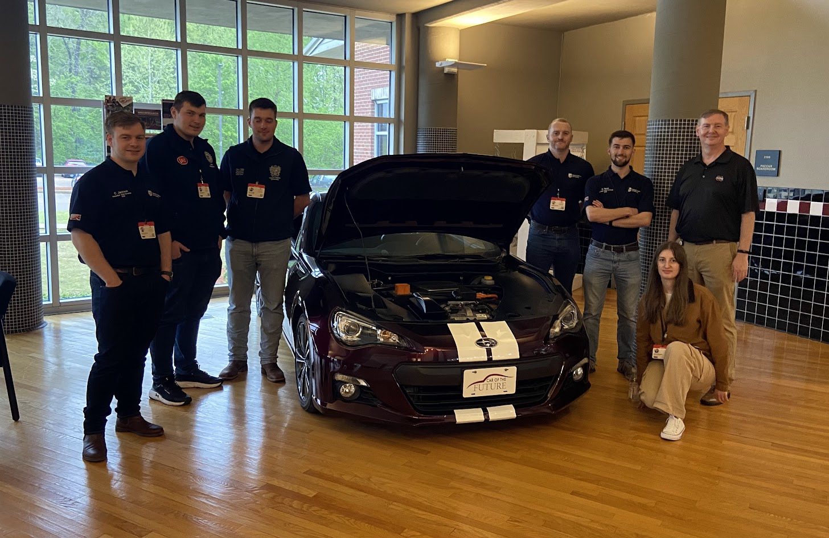
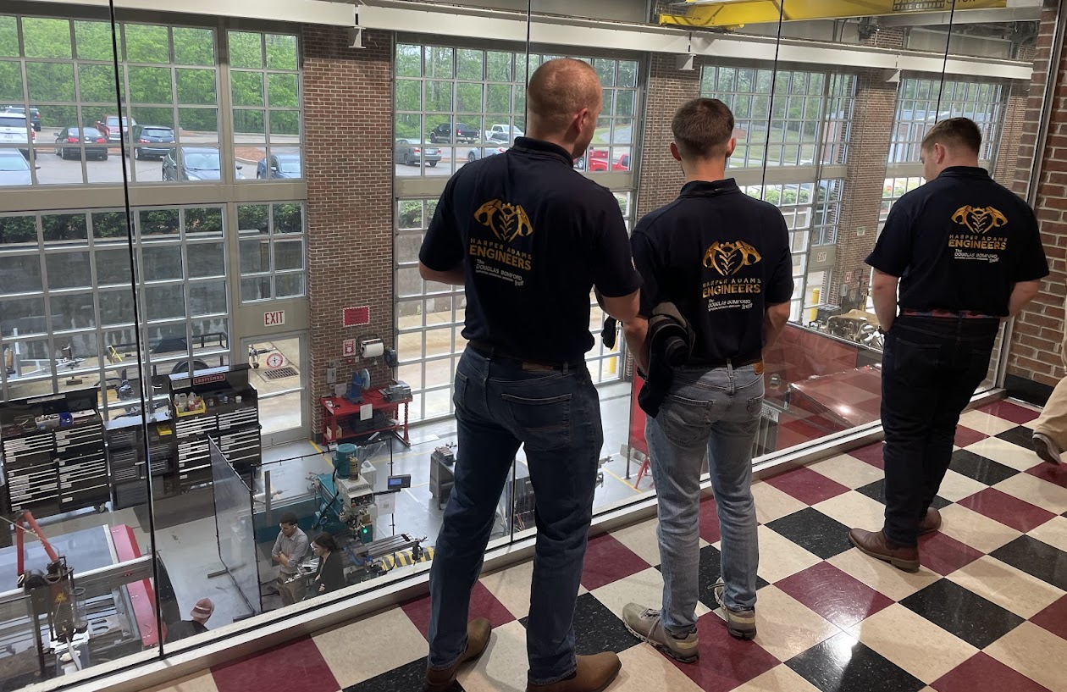
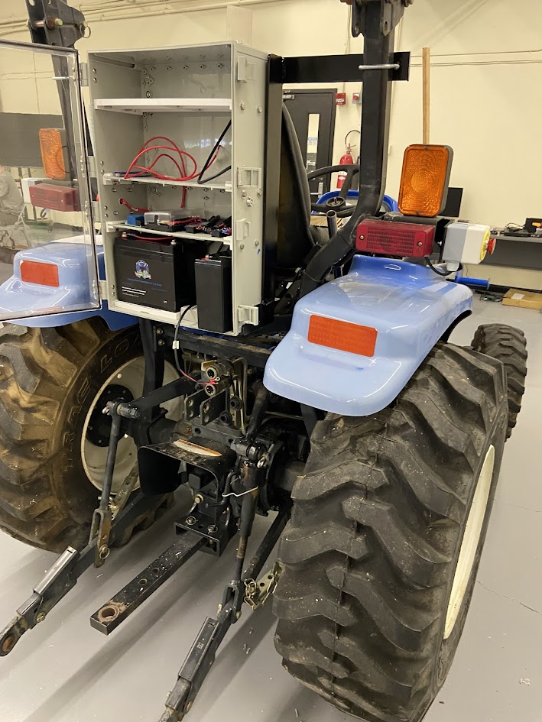
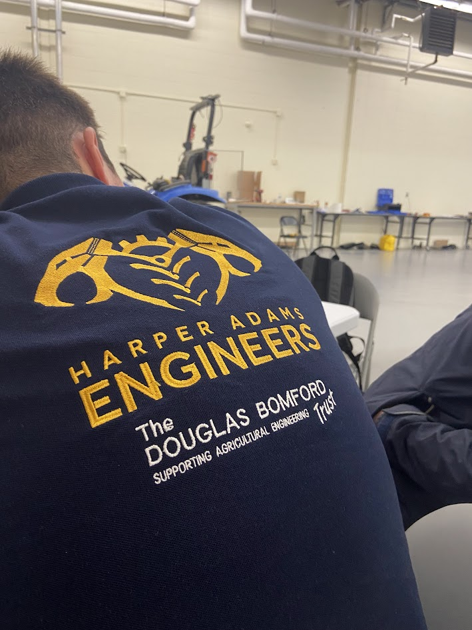

Some links of interest…
https://www.linkedin.com/posts/mississippi-state-university-agricultural-autonomy-institute_msu-students-to-visit-uk-this-june-to-further-activity-7194381617518325760-7hwo?utm_source=share&utm_medium=member_desktop

https://www.linkedin.com/posts/mississippi-state-university-agricultural-autonomy-institute_as-we-reach-the-end-of-the-spring-semester-activity-7191453950158467074-LRil?utm_source=share&utm_medium=member_desktop

